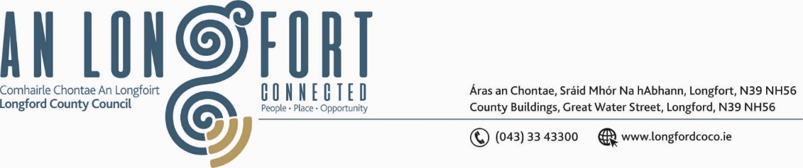

**GRANARD MUNICIPAL DISTRICT**

***Please note meeting will be held in Granard Library and via Microsoft Teams.***

**14 March 2022.**

**To: Each Member of Granard Municipal District.**

**Dear Member,**

You are requested to attend a Meeting of Granard Municipal District to be held

**via Microsoft Teams** on **Tuesday 22March 2022 at 3.30pm** to transact business, as set out on the Agenda hereunder.

**Yours sincerely**,

Ann Marie Mc Keon

______________________

**Ann Marie Mc Keon,**

**Meetings Administrator.**

**AGENDA**

Prayer before meeting.

**1.** Confirmation of Minutes as follows: -

* Granard Municipal District Meeting held on 25January 2022 – copy enclosed.
* Granard Municipal District Committee Meeting held on 25January 2022 – copy enclosed.

**2.** Matters arising from Minutes.

**3.** Declaration of Interest by Members.

**4.** Management Report incorporating Area Engineer’s Progress Report - enclosed.

**5.** Proposed Projects/Expression of interest – enclosed.

**6**. Consideration of Schedule of Granard Municipal District Works – enclosed

**7.** GMA 2022 - Town Twinning.

**8.** Special Projects/Discretionary Funds 2022.

**9. Notices of Motions, submitted by Councillors, as listed hereunder –**

**Councillor PJ Reilly**

(i) “I call on Longford County Council to install public lighting on the roadway at the rear of Granard Garda station leading up to the four industrial units”.

(ii) “I call on Longford County Council to realign the junction at Mackens Filling station Granard on the N55 leading on to the R194 to be realigned. This junction is waiting for a serious accident to happen presently with the way it is designed currently”.

**Councillor Colin Dalton**

(i) “I call on Longford County Council to carry out safety measures on the hill of Ballinalee to include traffic calming measures, ramps, slow down signs and flashing lights to stop speed and prevent accidents”.

**Councillor Turlough Mc Govern**

(i) “I call on Longford County Council to conduct a Low-Cost Safety Scheme at Ballingall cross on the approach to the main Gowna to Granard road as there are no roads markings on said approach, plus at The Pipers cross no signage. It is a major safety issue on this very busy road”.

(ii) “I call on Longford County Council to consider a yellow box junction outside the Credit Union on Tromra Road as due to increased traffic and parking an issue , residents and road user are in a constant battle with illegal parking blocking the road for drivers and pedestrians”.

(iii) Is there an update on the extra wheelchair assigned parking bays in Granard Town.